2019 Military Airworthiness Conference kicks off in Vilnius

Vilnius, Lithuania - 09 October, 2019

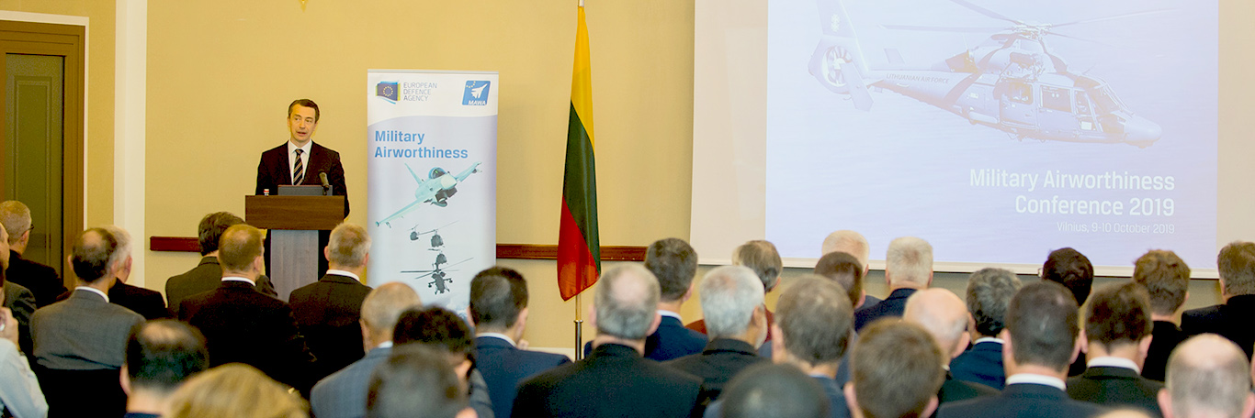

**EDA’s 2019 Military Airworthiness Conference, a two-days event organised with the support of the Lithuanian Ministry of Defence, was opened today in Vilnius by EDA’s Deputy Chief Executive Olli Ruutu.**

The conference brings together key stakeholders from national authorities, industry, European agencies and international organisations, to exchange views and best practices related to the harmonisation of European military airworthiness rules and standards. Common airworthiness approaches and standards are viewed as critical enablers for enhanced European defence cooperation.

Over the two days, four main topics are being addressed through specific sessions: i) the impact of European Military Airworthiness Requirements (EMARs) on military aviation; ii) opportunities and challenges related to that; iii) lessons learned from EMARs implementation so far; iv) and the experiences made by third-party stakeholders.

Good progress made over past 10 years

In his opening speech, EDA Deputy Chief Olli Ruutu thanked the Lithuanian Armed Forces for hosting the event and for their strong interest in the work of the Military Airworthiness Authorities (MAWA) Forum and the harmonisation of airworthiness approaches.

Since work started ten years ago on the harmonisation of airworthiness approaches in Europe, much has been achieved, Mr Ruutu said.  *“The majority of EDA participating Member States have already implemented or are in the process of implementing European Military Airworthiness Requirements in their national regulations. But as you all are aware, the implementation of EMARs is not only about translating them in regulations but also about turning them into practice. And that makes EMAR implementation the most important phase in the harmonisation process and crucial for gaining the full benefits”*, he stressed. Implementing the EMARs often means a different approach to military airworthiness that requires a change in safety culture, the Deputy Chief Executive stated.

Further progress is also required as regards the cooperation between the national military airworthiness authorities in Europe, a topic which is already in the focus of the MAWA Forum.  *“Since last year when the MAWA Forum adopted a new airworthiness roadmap, the forum has started several activities to develop harmonised practices and procedures with the objective to increase the level of standardisation and cooperation in the area of initial approvals of and oversight over organisations that provide services in the military airworthiness domain”*, Mr Ruutu recalled. In parallel, Member States are engaged in mutual recognitions. *“At this stage, 35 active recognitions are already in place between EDA pMS and several recognitions have been concluded with Military Airworthiness Authorities from other countries worldwide. These recognitions familiarise nations with each other’s airworthiness systems. It facilitates the exchange of lessons learned and the development of best practices and helps to build mutual trust and confidence, which are the cornerstones for cooperation”*, Mr Ruutu welcomed. 

Towards aligning the national airworthiness systems

Based on this, Member States should now consider which additional cooperation steps they could take in the area of military airworthiness in line with their PESCO commitments, he said. *“I believe it is now good to reflect on the best cooperative working structures for military airworthiness authorities; keeping in mind that we need to ensure that we are as effective as possible in aligning the national airworthiness systems towards a single reference without affecting national sovereignty as regards airworthiness risk acceptance. We need to facilitate an increased efficiency in certification, approval and oversight activities but also provide industry with a single framework to meet the requirements of all participating Member States”*, Mr Ruutu said.

Background

The Military Airworthiness Authorities (MAWA) Forum oversees the development and maintenance of the European Military Airworthiness Requirements (EMARs) and promotes ways and means to harmonise the military airworthiness oversight across Europe.